Document Summary

This document is an analysis of the energy use and costs associated with the energy use of fleet operated buildings within Baltimore City. The buildings that are being analyzed include:

- DOT Maintenance - DGS Fleet Heavy Equipment Mechanic Shop (6210 Pulaski Hwy, B00069, Baltimore, MD 21205, United States)

- Northeast DGS Fleet Substation (4325 York Rd, Baltimore, MD 21212, United States)

- Fleet Central Garage Main Building (3800 E Biddle St, Baltimore, MD 21205, United States)

- Fallsway Fueling Station Garage (410 N Front St, Baltimore, MD 21202, United States)

- Fallsway Impound Lot and Office (411 Fallsway, Baltimore, MD 21202, United States)

- Fallsway Substation (201 Fallsway, Baltimore, MD 21202, United States)

- Northwest Substation (4410 Lewin Ave, Baltimore, MD 21215, United States)

Document Summary (Continued)

Energy use within these fleet operated buildings primarily increased from FY 2023/2024 to FY 2024/2025, which also resulted in an increase of costs for those buildings between those fiscal years as well. However, the “DOT Maintenance - DGS Fleet Heavy Equipment Mechanic Shop” is a unique outlier, as it is the only fleet operated building that has shown a decrease in energy use from fiscal year 2023/2024 to fiscal year 2024/2025, which resulted in a decrease of costs between those fiscal years.

Fleet Operated Buildings: Total Energy Use and Costs

FY | Total Cost in Relation to Energy and Commodity Use | Total Energy Use
2023/2024 | $267,006 | 13,343,621 Kbtu
2024/2025 | $313,137 | 13,162,676 Kbtu

- From FY 2023/2024 to FY 2024/2025, there was a $46,131 increase in cost, in relation to energy and commodity use for the listed fleet operated buildings (in total/altogether).

- From FY 2023/2024 to FY 2024/2025, there was a 180,945 (Kbtu) decrease in energy use for the listed fleet operated buildings (in total/altogether).

Individual Building Specifications

- DOT Maintenance - DGS Fleet Heavy Equipment Mechanic Shop

- From fiscal year 2023/24 to fiscal year 2024/25, the yearly energy use of this building decreased by 5,145 (Kbtu), and the cost decreased by $92.
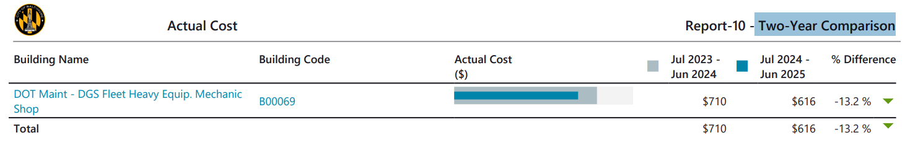

FY23/24

FY24/25
- Northeast DGS Fleet Substation

- From fiscal year 2023/24 to fiscal year 2024/25, the energy use unit cost use of this building increased by $0.010, and the commodity use unit cost of this building also increased, which ultimately lead to a $3,214 increase in total cost.

- However, there was a 37,245 (Kbtu) decrease in energy use from the 2023/24 to fiscal year 2024/25.

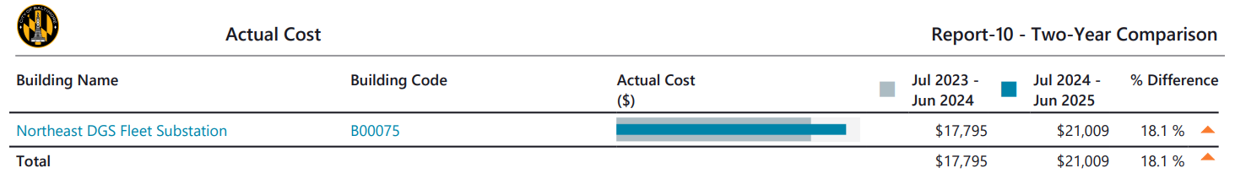

FY23/24

FY24/25

- Fleet Central Garage Main Building

- From fiscal year 2023/24 to fiscal year 2024/25, the unit costs in terms of commodity use and energy use both increased, which resulted in a $30,731 increase in total cost.

- However, there was a 141,652 (Kbtu) decrease in energy use from 2023/24 to fiscal year 2024/25.

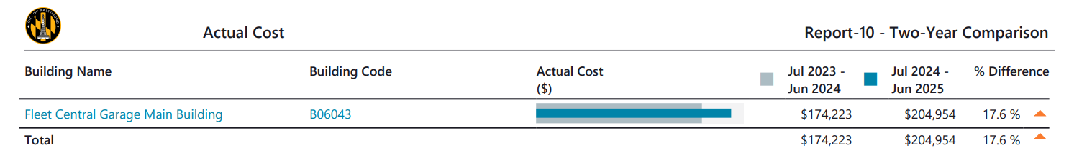

FY23/24

FY24/25

- Fallsway Fueling Station Garage

- From fiscal year 2023/24 to fiscal year 2024/25, the unit costs in terms of commodity use and energy use both increased, which resulted in a $1,891 increase in total cost.

- However, there was a 56,291 (Kbtu) decrease in energy use from fiscal year 2023/24 to fiscal year 2024/25.

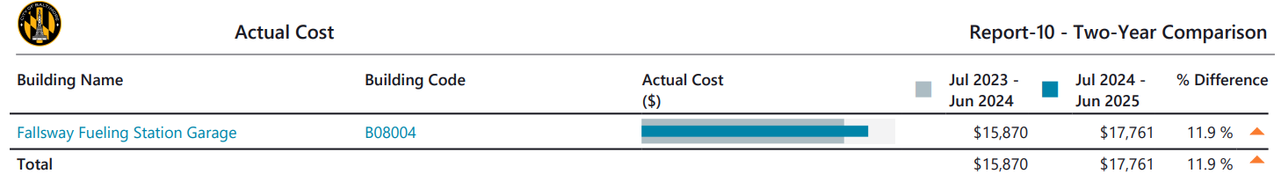

FY 23/24

FY 24/25

- Fallsway Impound Lot and Office

- From fiscal year 2023/24 to fiscal year 2024/25, the unit costs in terms of commodity use and energy use both increased, which resulted in a $329 increase in total cost.

- However, there was a 1,747 (Kbtu) decrease in energy use from fiscal year 2023/24 to fiscal year 2024/25.

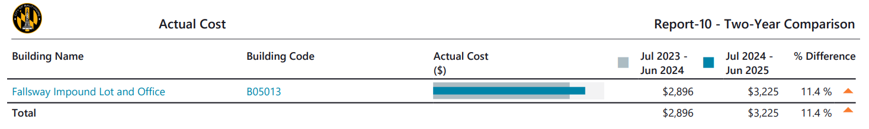

FY23/24

FY24/25

- Fallsway Substation

- From fiscal year 2023/24 to fiscal year 2024/25, the unit costs in terms of commodity use and energy use both increased, which resulted in a $5,657 increase in total cost.

- However, there was a 102,314 (Kbtu) decrease in energy use from fiscal year 2023/24 to fiscal year 2024/25.

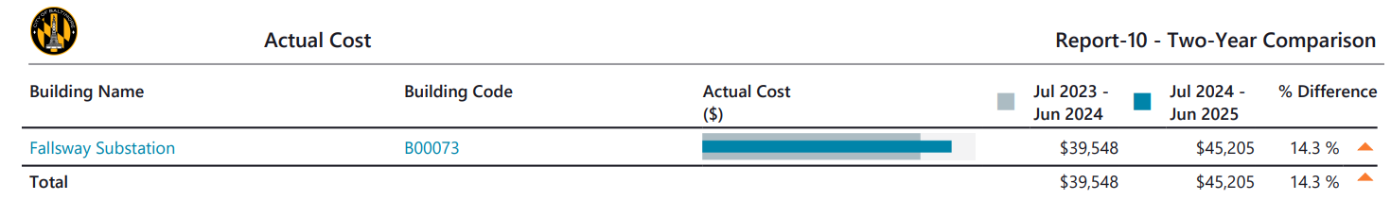

FY23/24

FY24/25

- Northwest Substation

- From fiscal year 2023/24 to fiscal year 2024/25, energy use and natural gas use both significantly increased, which resulted in a $4,403 increase in total cost.

- More specifically, there was a 163,449 (Kbtu) increase in energy use from fiscal year 2023/24 to fiscal year 2024/25.

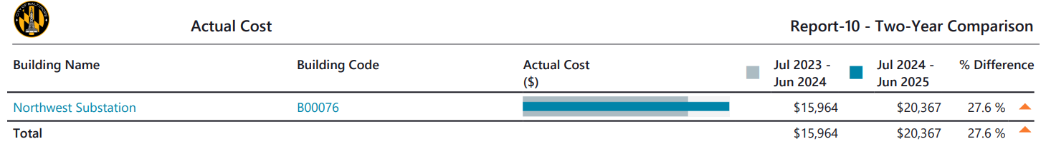

FY23/24

FY24/25

